**REPORT**

**IBM: REAL TIME RIVER WATER QUALITY MONITORING AND CONTROL SYSTEM**

**Dashboard**

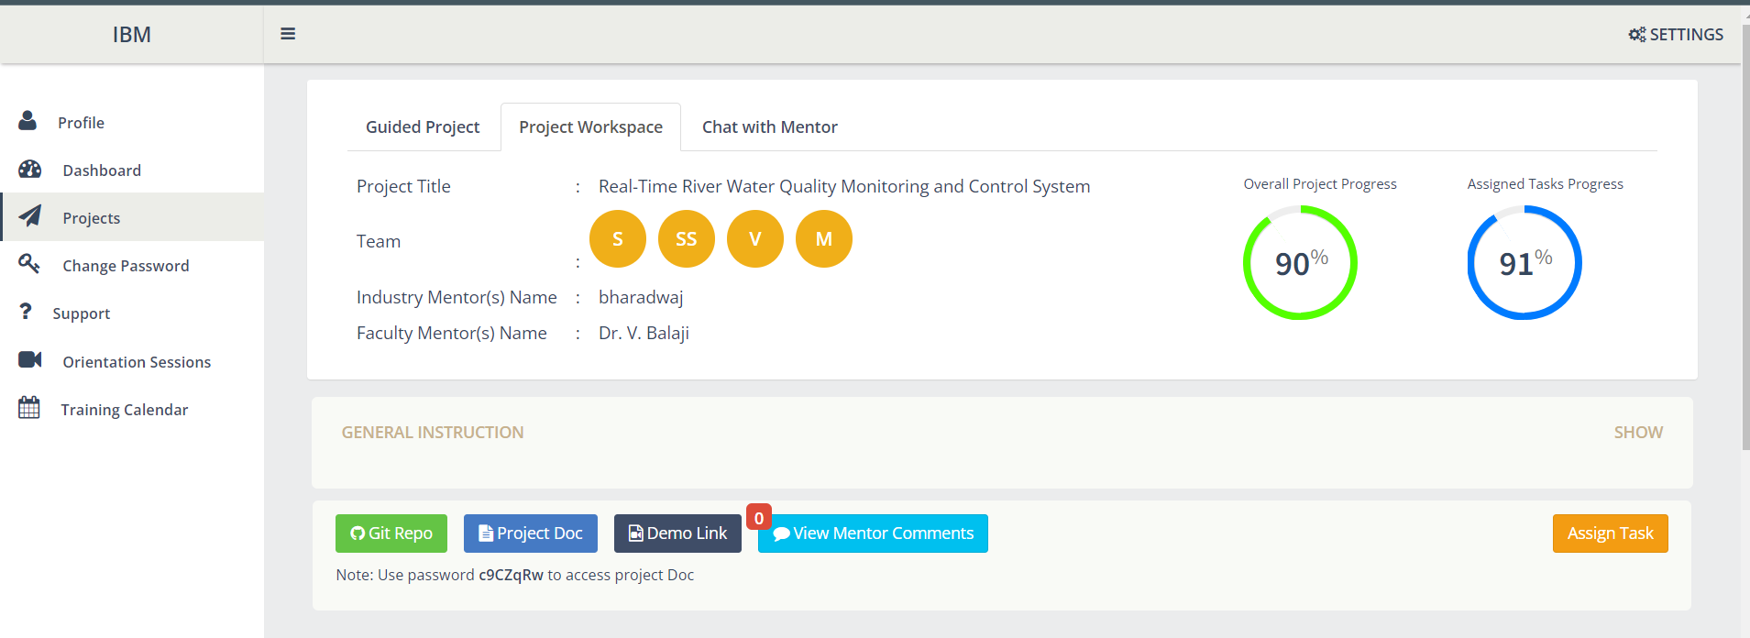

**Task and Progress**

1. **Prerequisites**

IBM Cloud Services – Monisha (In-progress)

1. **Ideation Phase**

Prepare Empathy Map – Assigned to all (Review)

Literature Survey – Assigned to all (Completed)

Ideation – Assigned to all (Review)

Brainstorm and idea prioritization - Assigned to all

Problem statement- Assigned to all

1. **Project design phase 1**

Proposed solution - Assigned to all(Review)

Problem solution fit - Assigned to all(Review)

Solution architecture - Assigned to all(Review)

1. **Project design phase 2**

Customer journey - Assigned to Sweety Sharon (In-progress)

Data flow chart - Assigned to Sandhiya (In-progress)

Functional requirement - Assigned to Vinisha (In-progress)

Technology architecture - Assigned to Monisha (In-progress)